Date: | 16/03/2022
Order#: | 22001
Valid Time: | within 15days

LAYOUT : 6.9*4.1*2.8/2.6m
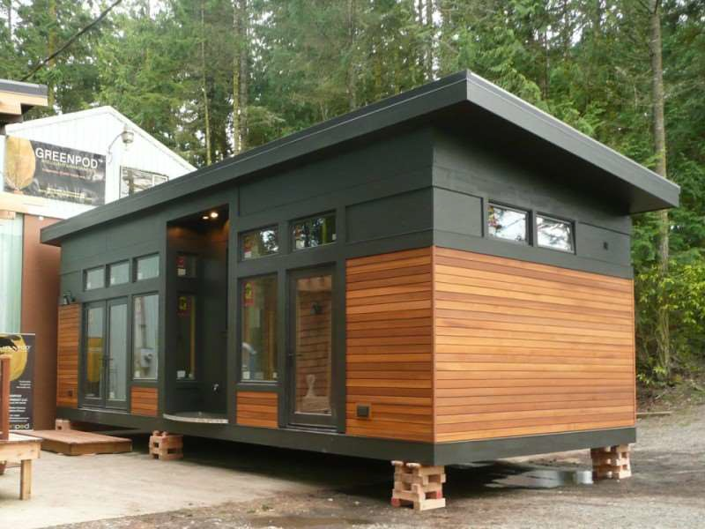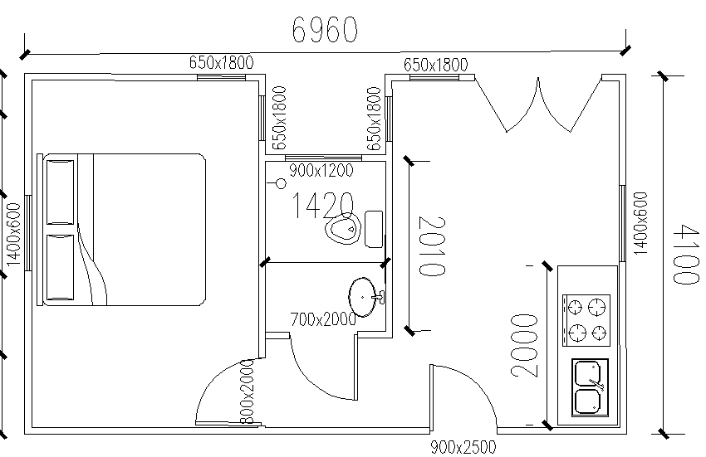
Body house quotation
S/N | Material | Dimension | Specification | Quantity | unit
1 | Galvanized steel base | 6960*4100mm (L*W) | galvanized steel & C-type 2mm, square tube 40*60*1.5mm & MGO board floor 15mm &steel sheet channel | 28.5 | m2
2 | Galvanized steel column | 2800mm &2600mm (H) | U type welding 80*40*2mm | 8 | pcs

3 | EPS sandwich wall panel | 75mm thickness foam | steel sheet+75mm EPS foam+steel sheet |  | 81 | m2
4 | EPS sandwich roof panel | 75mm thickness foam | steel sheet+75mm EPS foam+steel sheet |  | 35 | m2
5 | Accessories parts | 75*40*0.5mm | 0.5mm steel sheet cover for top wall and ground channel |  | 1 | set
6 | Aluminum double open door | 1500*2500mm | aluminum frame with double glass |  | 1 | pcs
7 | aluminum single door | 950*2500mm | aluminum frame with double glass |  | 1 | pcs
8 | aluminum long window | 650*1800mm | aluminum frame with double glass |  | 4 | pcs
9 | aluminum narrow window | 1400*600mm | aluminum frame with double glass |  | 2 | pcs
10 | aluminum normal window | 900*1200mm | aluminum frame with double glass |  | 1 | pcs
11 | inside door for bedroom and bathroom | 800*2000mm | wood dodor |  | 2 | pcs
12 | connecting by bolts and nails |  |  |  | 1 | set
13 | FOB cost | from xingang port to our factory and back to Xingang port
Total 1set body empty house FOB Xingang China FOB USD |  |  |  |  | 9,900
Option quotation
S/N | Material | Dimension | Specification | Quantity | Unit
1 | SPC floor |  |  | 31.5 | m2
2 | wood cladding for outside wall |  |  | 48.84 | set
3 | aluminum board for cover outside window |  |  | 24.42 | m2
4 | no bamboo powder board for inside wall and ceiling decoration |  |  | 0 | m2
5 | sanitary fitting |  |  | 1 | set
6 | precast wire in the wall |  |  | 1 | set
7 | electrical fitting |  |  | 1 | set

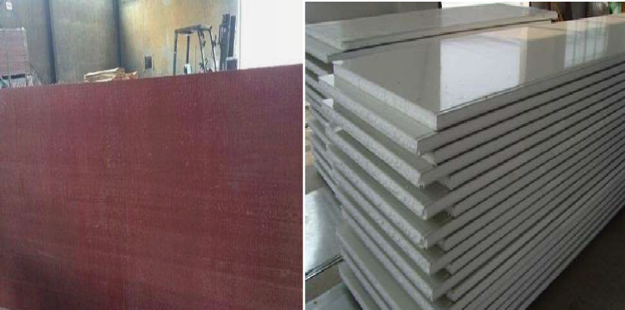
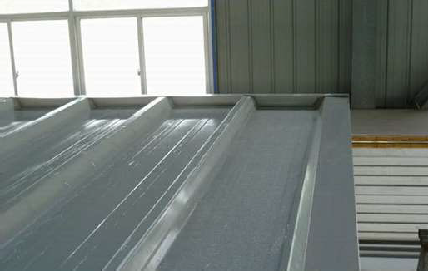
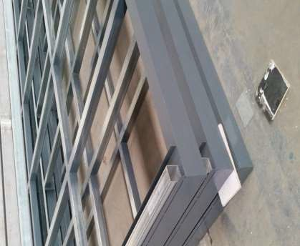
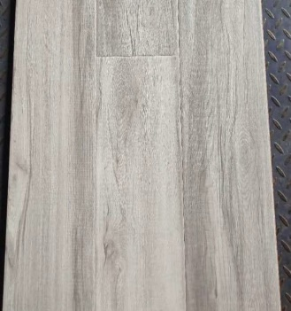
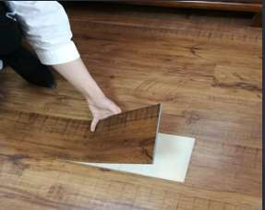
8 | no bamboo fiber board for inside wall and ceiling |  |  | 0 | m2
9 | no kitchen cabinet |  |  | 0 | set
 | total option price
 | Total 1set house price with options |  | FOB USD | 14,250
 | Total 4sets house price |  | FOB USD | 57,000
 | sea freight from Xingang
Terms and conditions
1.price terms: FOB
2. order quantity: 4sets (Loading: in 1x40HQ container.)
3.payment terms: Total by T/T. 50%deposit in advance, 50% the balance before shipment.
4.delivery term: within 30days after receiving deposit.
The Customer Requets
1. Steel base & Mgo board floor 2.EPS sandwich panel 75mm 3.composite floor/stone plastic floor

4.aluminum narrow window and double opening and single door inside wood door |  | 5.electrical fitting
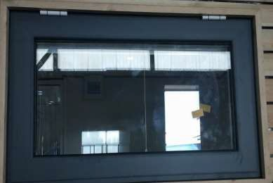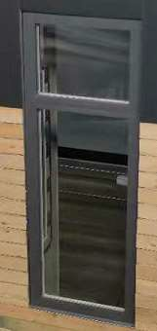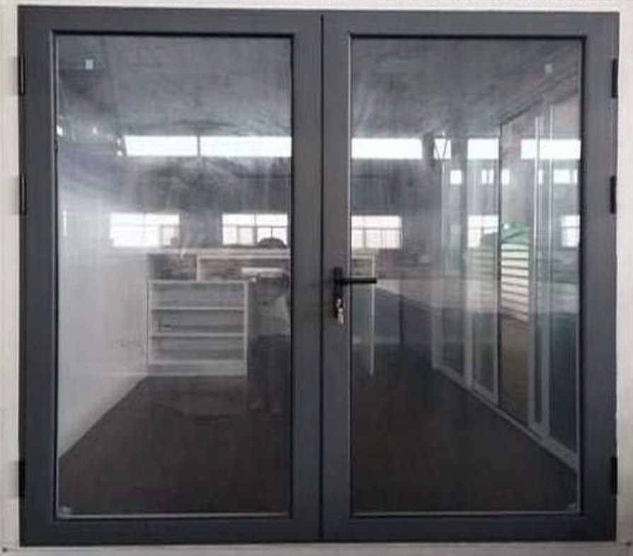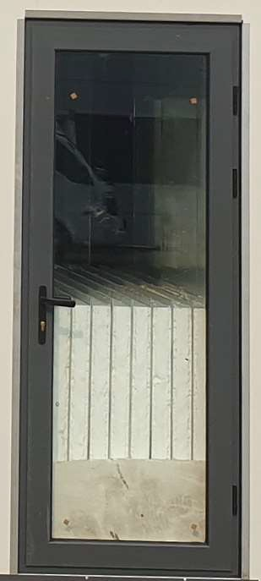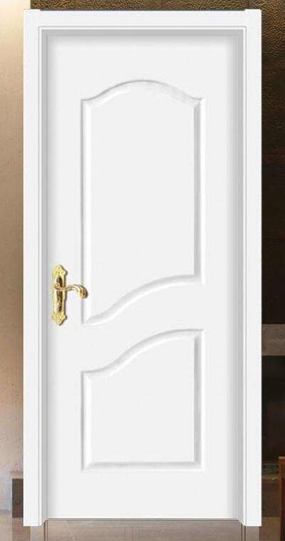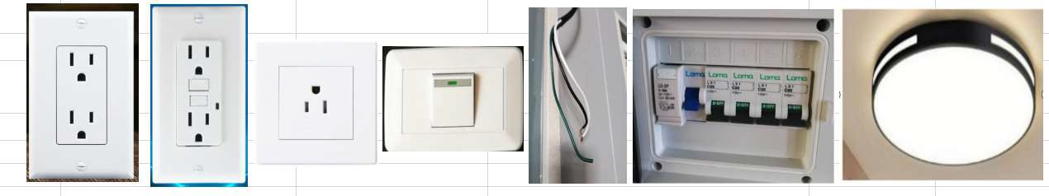

6.precast wrie in the wall | 7.preserving wood wall cladding aluminum board 7. sanitary fitting
